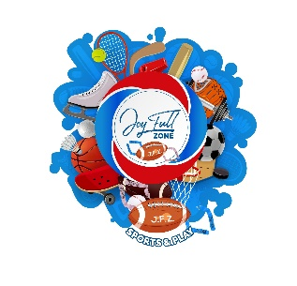
REFUND POLICY
The policy of the Joy Full Zone Sports is to issue no refunds after a child has played in a sanctioned game, attended class or practice. Prior to playing in a sanctioned game, class or practice a refund of the registration fee can be requested excluding the $50 or 45% whichever is chosen for administrative handling fee. Credit for future programs is an option and will hold the value of 100%. The JFZ Sports reserves the right to reschedule activities due to circumstances beyond its control.

PRIVACY POLICY
Joy Full Zone Sports only collects personal information when you request our services and only uses the information collected to provide those services for you. If you choose to make a purchase, you will be asked to provide contact information (such as your name and shipping address) and financial information (such as your credit card number and expiration date). This information is used for billing purposes and to process your order. Joy Full Zone Sports handles all of this data with the utmost confidentiality.

THIRD PARTIES
Any personal information provided will not be traded, rented, sold or otherwise shared with anyone outside of Joy Full Zone Sports, or used for reasons beyond those contemplated in this statement. From time to time, we may engage third parties to process your information on our behalf; however, none of Joy Full Zone Sports affiliates (such as our credit card company) have permission to retain, share, store or use personal information for any reason other than providing the requested service.

SECURITY
To prevent unauthorized access, disclosure and improper use of your information, we have established appropriate physical, electronic, and managerial safeguards to protect the information we collect in accordance with our privacy policy.
Your payment and personal information is always safe. Our Secure Sockets Layer (SSL) software is the industry standard and among the best software available today for secure commerce transactions. It encrypts all of your personal information, including credit card number, name, and address, so that it cannot be read over the internet." (etc.)
Furthermore, your credit card number, expiration date and CSV code is never stored in our systems.
Our systems are routinely scanned by a third party provider for security vulnerabilities in compliance with the policies of VISA / MASTERCARD.
TERMS AND CONDITIONS - Joy Full Zone Sports
AGREEMENT BETWEEN USER AND Joy Full Zone Sports.
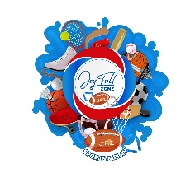
The network of Joy Full Zone Sports operated by Joy Full Zone Sports or its affiliates or subsidiaries, is comprised of various Web sites and Web pages.
The Joy Full Zone Sports are offered to you conditioned on your acceptance without modification of the terms, conditions, and notices contained herein. Your use of the Joy Full Zone Sports Web Site constitutes your agreement to all such terms, conditions, and notices. Your use of a particular Joy Full Zone Sports website included within the Joy Full Zone Sports. Web Sites network may also be subject to additional terms outlined elsewhere on that website (the "Additional Terms"). Additionally, the Joy Full Zone Sports. Web Site may themselves contain additional terms that govern particular features or offers (for example, sweepstakes or chat areas). In the event that any of the terms, conditions, and notices contained herein conflict with the Additional Terms or other terms and guidelines contained within any particular Joy Full Zone Sports website, then these terms shall control.

PLEASE READ THE FOLLOWING TERMS OF USE AND DISCLAIMERS CAREFULLY BEFORE USING THIS WEB SITE (this "Site").
By accessing or using this Site, you agree to these terms of use, conditions and all applicable laws. If you do not agree to these terms you may not use this Site.

MODIFICATION OF THESE TERMS OF USE Joy Full Zone Sports reserves the right to change the terms, conditions, and notices under which the Joy Full Zone Sports websites are offered, including but not limited to the charges associated with the use of Joy Full Zone Sports websites. You are responsible for regularly reviewing these terms and conditions.

USE OF SITE, PERSONAL AND NON-COMMERCIAL USE LIMITATION
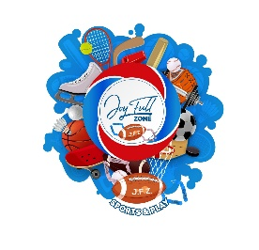
Unless otherwise specified; the Joy Full Zone Sports websites are for your personal and noncommercial use. You may not modify copy, distribute, transmit, display, perform, reproduce, publish, license, create derivative works from, transfer, or sell any information, software, products or services obtained from the Joy Full Zone Sports sites. You may display and, subject to any expressly stated restrictions or limitations relating to specific material, electronically copy, download and print hard copy portions of the material from the different areas of the Site solely for your own noncommercial use, or to place an order with Joy Full Zone Sports or to purchase Joy Full Zone Sports products. Any other use of materials on this Site, including but not limited to the modification, reproduction, distribution, republication, display or transmission of the content of this Site, without prior written permission Joy Full Zone Sports is strictly prohibited. Harassment in any manner or form on the Site or any of the Joy Full Zone Sports websites, including via e-mail and chat or by obscene or abusive language is strictly forbidden. Impersonation of others, including a Joy Full Zone Sports employee, host, or representative or other members or visitors on the Site is prohibited. You may not upload to, distribute, or otherwise publish through the Site any content which is libelous, defamatory, obscene, threatening, invasive of privacy or publicity rights, abusive, illegal, or otherwise objectionable, or which may constitute or encourage a criminal offense, violate the rights of any party or otherwise give rise to liability or violate any law. You may not upload commercial content on the Site or use the Site to solicit others to join or become members of any other commercial online service or other organization.

COPYRIGHTS AND TRADEMARKS
The entire content included in this site, including but not limited to text, design, graphics, interfaces, or code and the selection and arrangements thereof is copyrighted as a collective work under the United States and other copyright laws, and is the property of Joy Full Zone Sports. The collective work includes works that are licensed to Joy Full Zone Sports. Copyright 2019 - Present. ALL RIGHTS RESERVED. All trademarks, service marks, and trade names (collectively the "Marks") are trademarks or registered trademarks of and are proprietary Joy Full Zone Sports, or other respective owners that have granted.

CONTACT US WITH QUESTIONS
Call us at 201-283-0924 and leave a message if you have any questions. Someone will call you back within 72 hours during the season.

